TC-DM-005
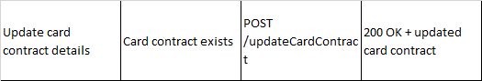
Card Before Update
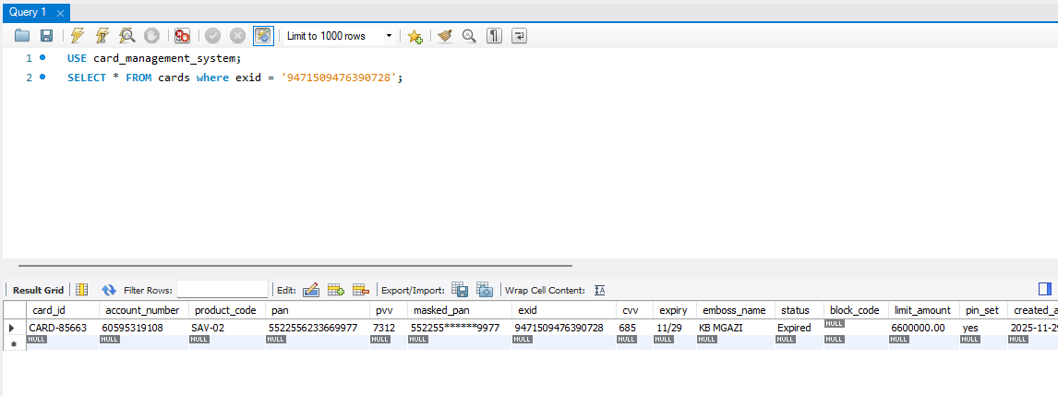
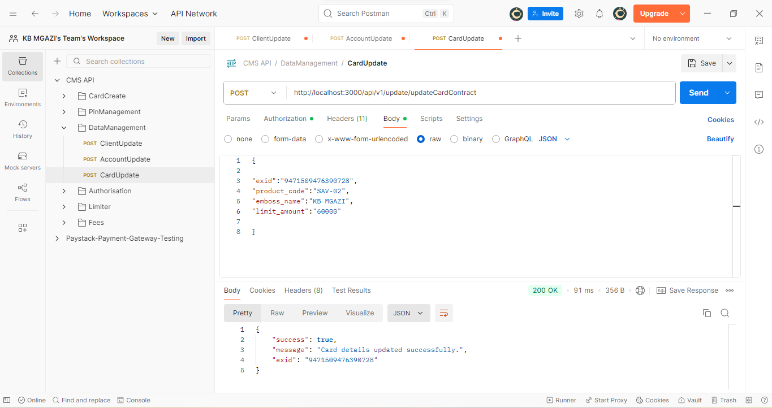
Request:
{

"exid":"9471509476390728",
"product_code":"SAV-02",
"emboss_name":"KB MGAZI",
"limit_amount":"60000"

}

Response:
{
"success": true,
"message": "Card details updated successfully.",
"exid": "9471509476390728"
}

